**EXPERIMENT NO. 6**

**AIM**: To simulate Enhanced Interior Gateway Routing Protocol (EIGRP) configuration using Cisco Packet Tracer.

**OBJECTIVES:**

i.

To create a topology to illustrate the use of EIGRP.

ii.

To configure router as EIGRP.

iii.

To use configured EIGRP from a remote PC or a remote router and test the

network connectivity.

iv.

To analyze the EIGRP routing

tables.

v.

To analyze the routing metric used by EIGRP.

vi.

To understand load balancing in EIGRP.

**SOFTWARE:**

Cisco Packet Tracer.

**SCENARIO:**

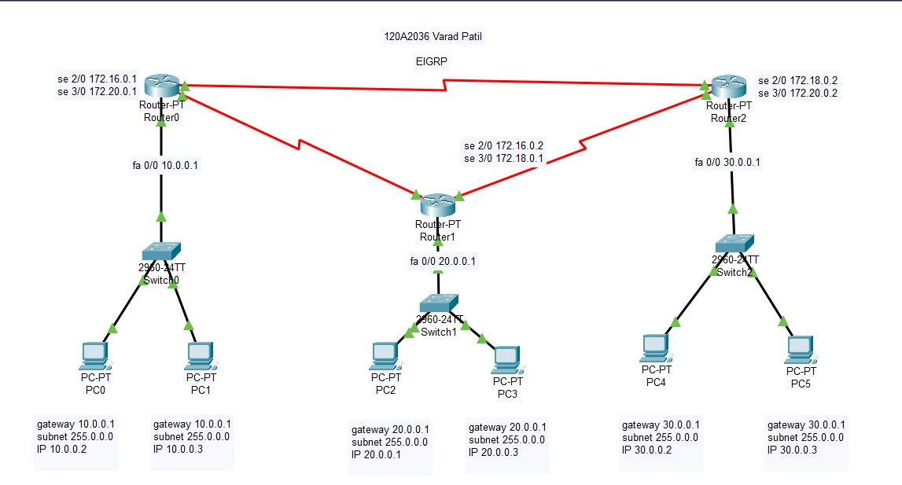

**Router0:**

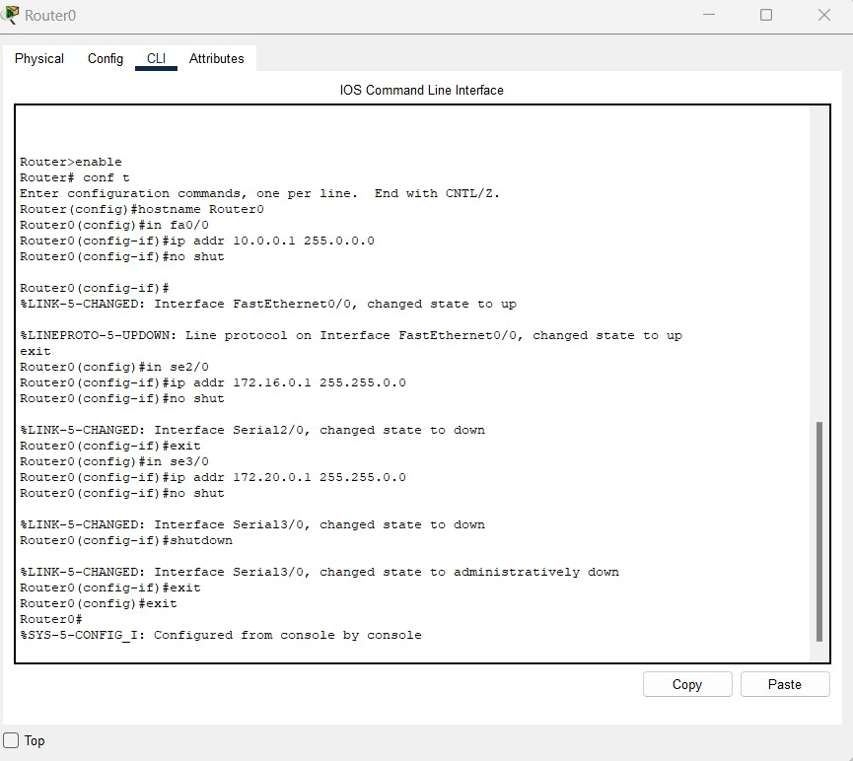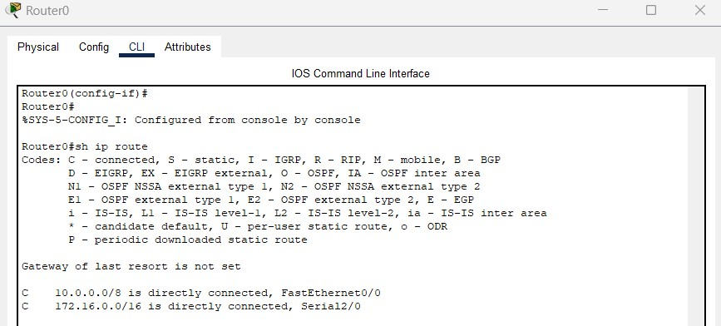

**Router1:**

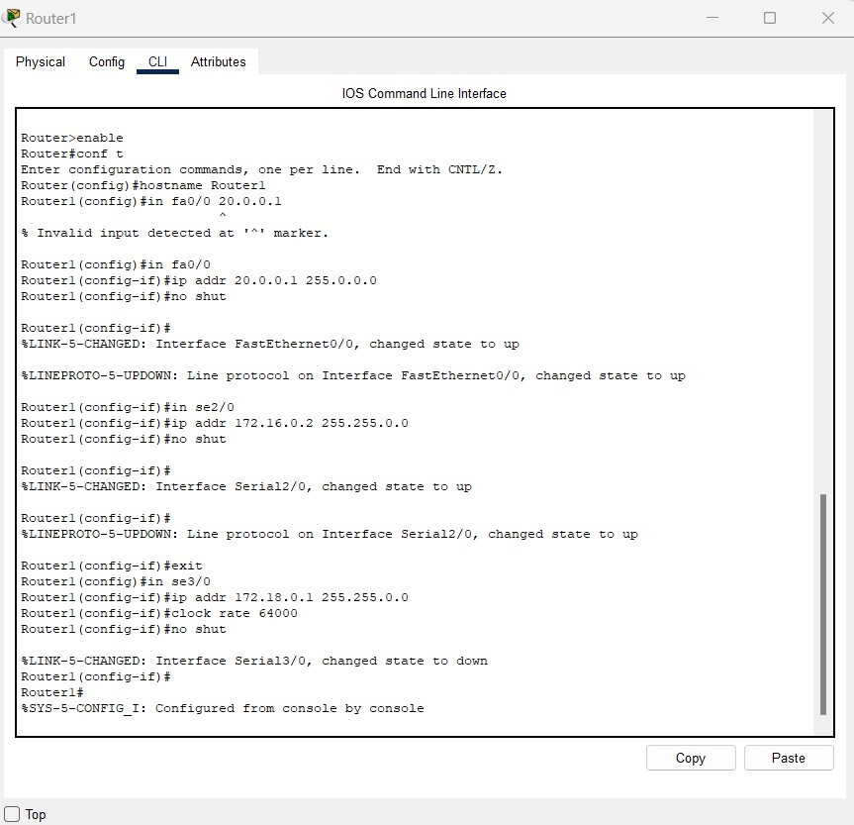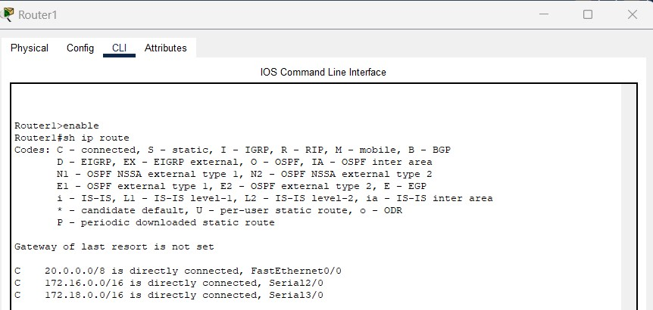

**Router2:**

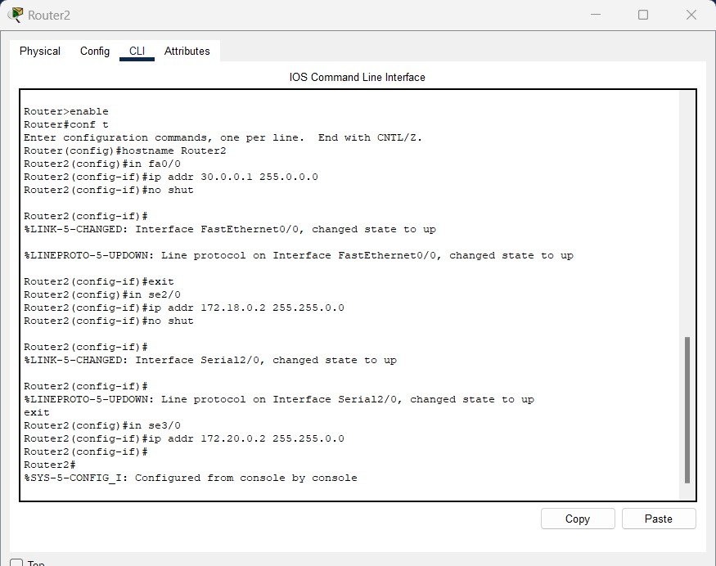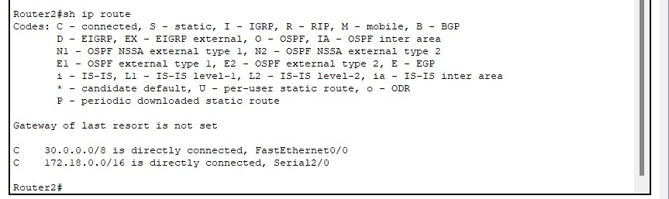

**EIGRP CONFIGURATION:**

**ROUTER0:**

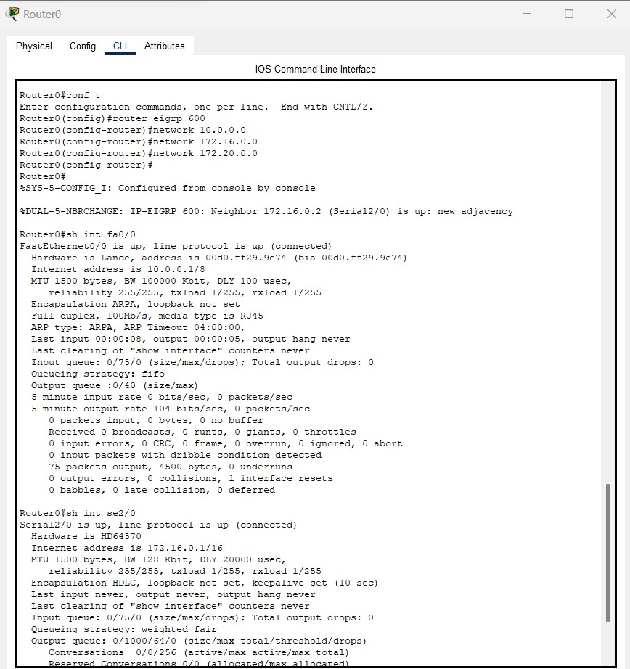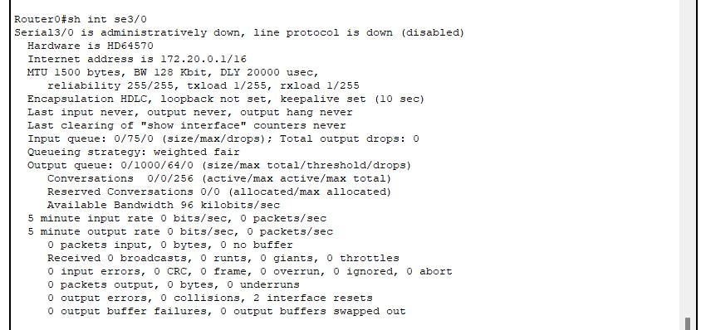

**ROUTER1:**

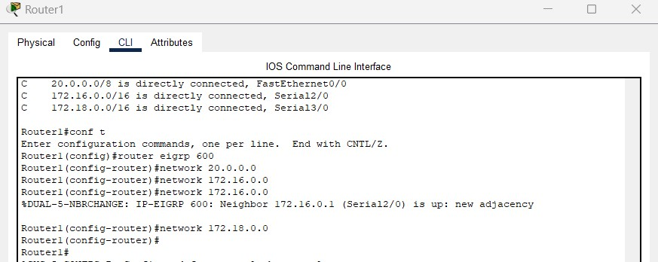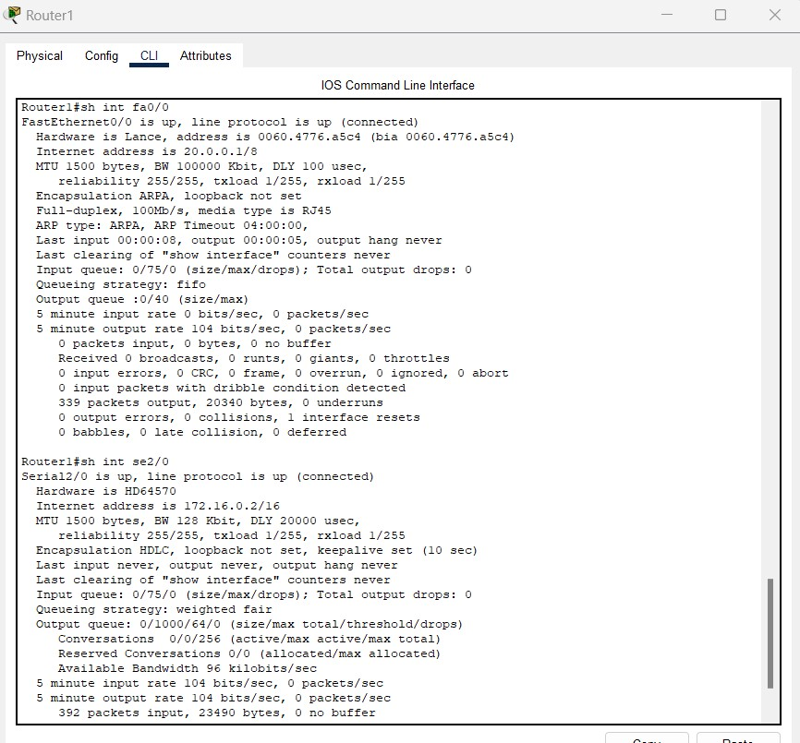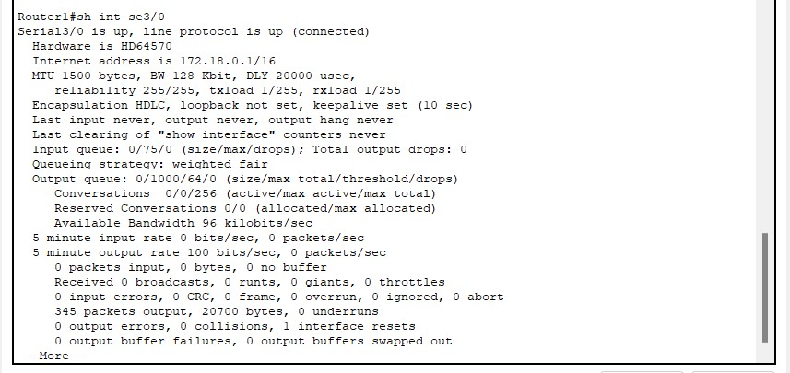

**ROUTER2:**

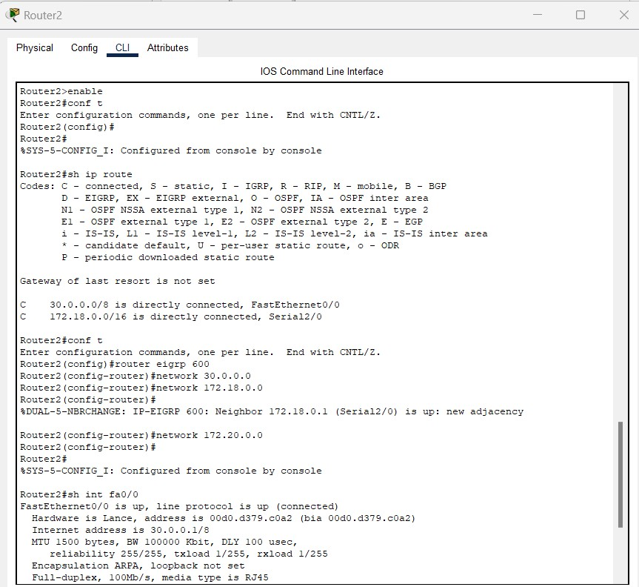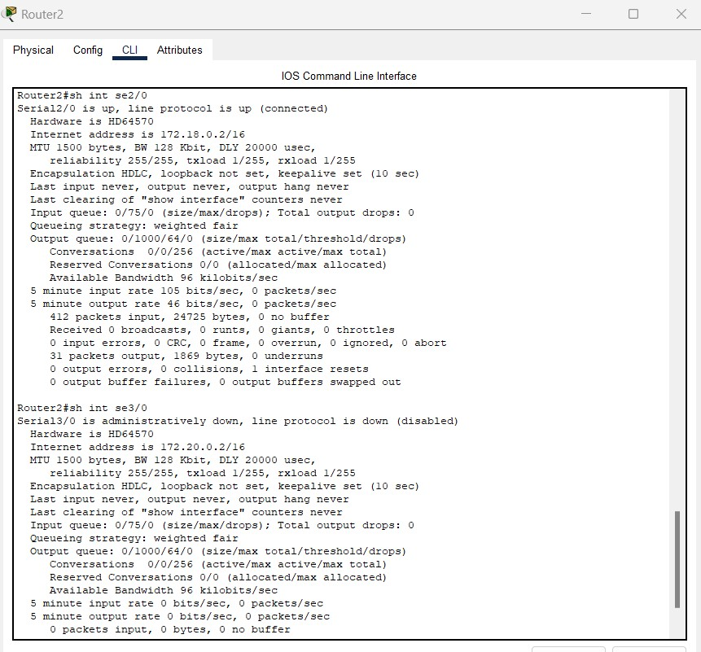

**INTERFACE BANDWIDTHS AND DELAYS:**

**ROUTER0:**

**ROUTER1:**

**ROUTER2:**

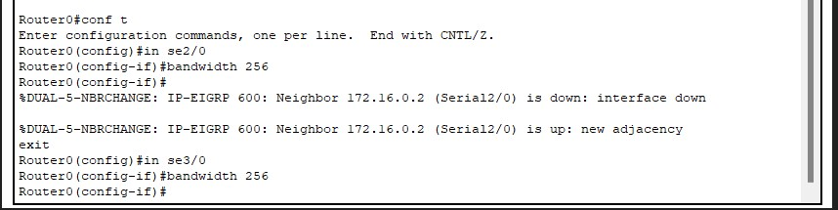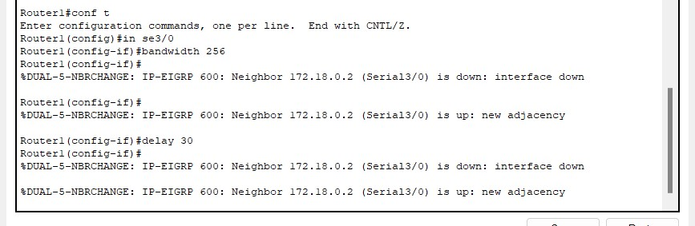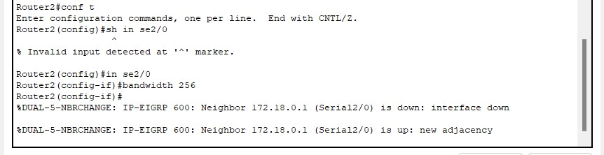

**UPDATED ROUTING TABLES:**

**ROUTER0:**

**ROUTER1:**

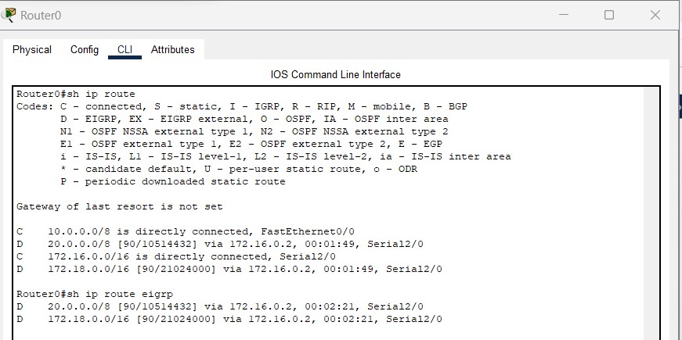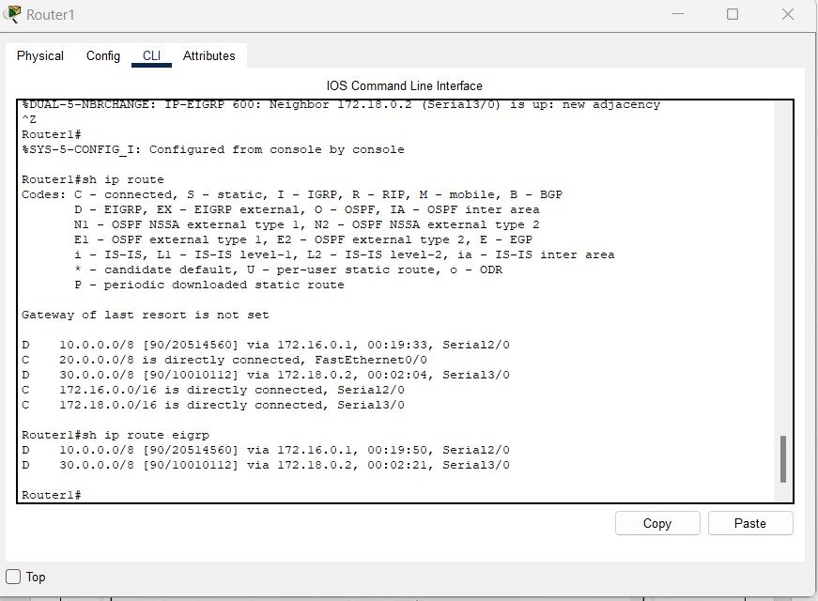

**ROUTER2**

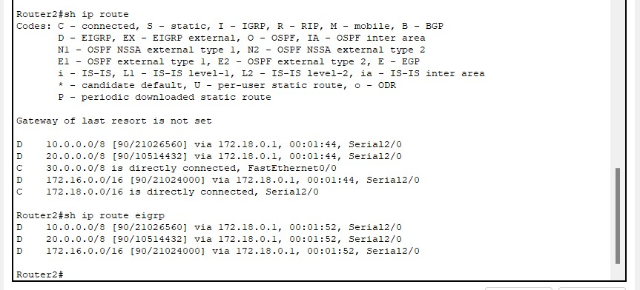 **EIGRP NEIGHBOR AND TOPOLOGY TABLES: ROUTER0:**

**ROUTER1:**

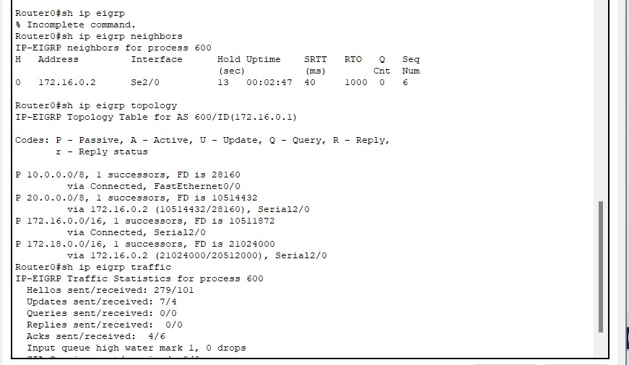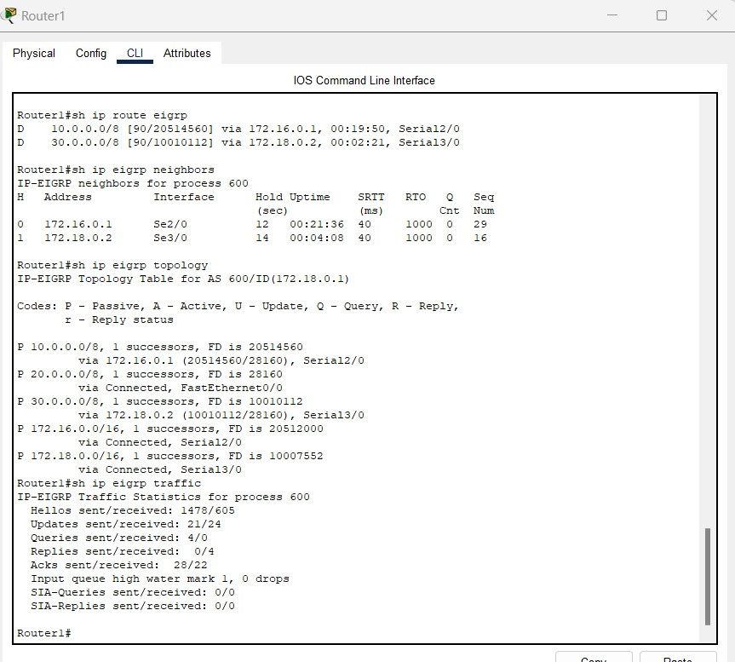

*Department of Electronics & Telecommunication Engineering, SIES Graduate School of Technology*

**ROUTER2:**

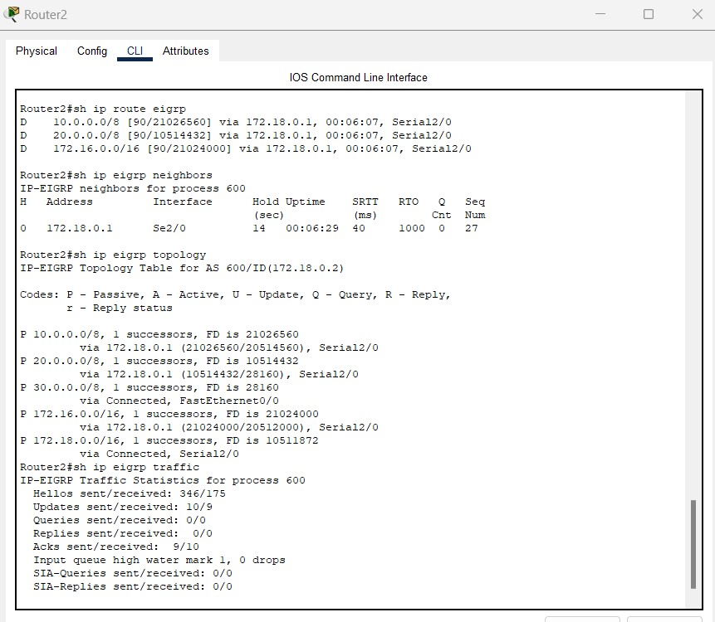

**PING RESPONSES:**

**ROUTER0:**

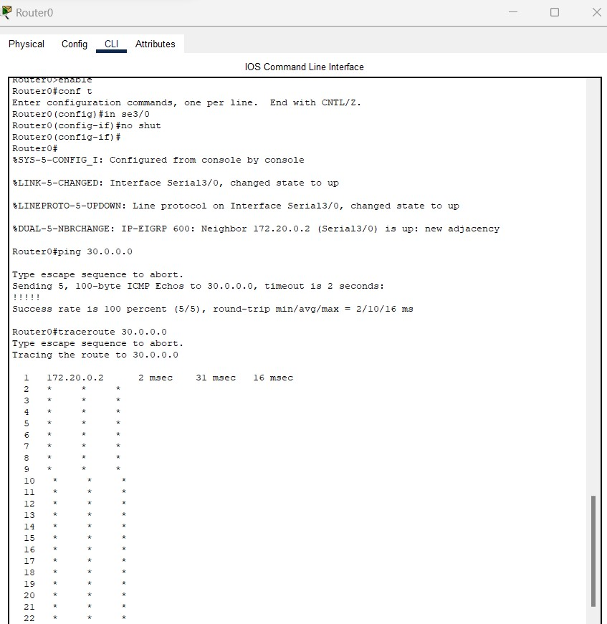

**ROUTER1:**

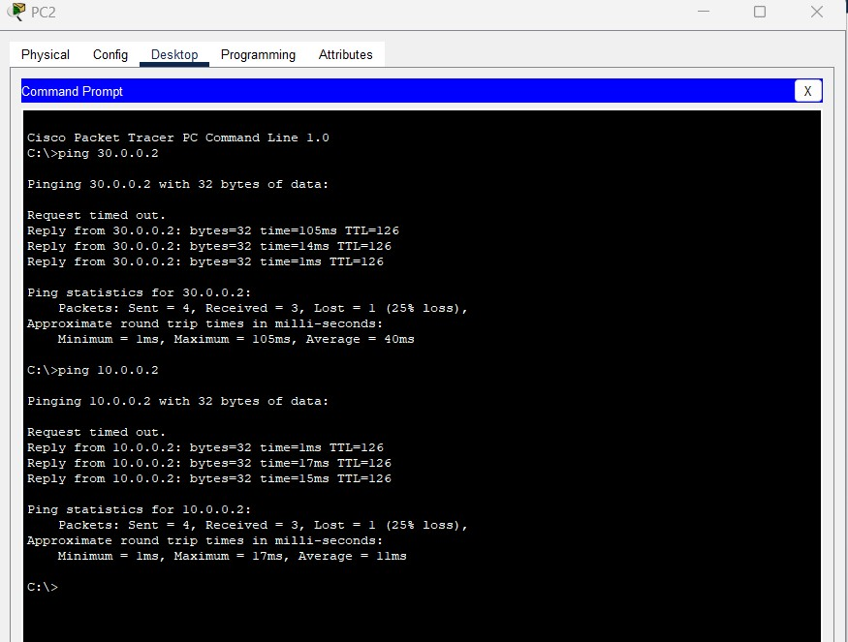

**ROUTER2:**

**CONCLUSION:**

S

imulat

ion

of

Enhanced Interior Gateway Routing Protocol (EIGRP) configuration

using Cisco Packet Tracer

was performed successfully.

